**Suggestions for safe and effective**

**Moth Plant eradication**

# for students and parents/guardians

1. **Watch this short video: https://bit.ly/3c9Zx9A**
2. If pods are located on private property, get permission from the landowner before you go on their land to remove moth plant pods or plants. If you do not know who the owner is, knock on the front door and ask. Please ensure that you do not do this on your own and be aware of dogs and other potential dangers.
3. Go with parents, older siblings or in a group. Do not go alone for moth pod gathering on other people’s property.
4. Keep yourself safe. Tell people where you are going, wear appropriate gear; old clothing that you don’t mind getting stained with moth plant sap. Wear covered shoes, gloves, long pants and protective or sunglasses as the sap can be a skin irritant.
5. Take a coffee sack to gather pods and small vines in so you can dispose of them appropriately. Bring them to the free public weed disposal bins at Lloyd Elsmore Park (Bells Road entrance) from 10th May to 13th May 2024. Bring your moth plant and the equipment used and take home a free native plant for your garden at our Weed Swap Event 11th May 2024, 9 am to 12 noon.
6. For small infestations, dig or pull out all seedlings and vines if practical. Place all pods and vines in the bags to take to landfill or weed swap.
7. Cut vines can be left in trees to die.
8. If you cannot dig out the plant, cut vines near the ground leaving approx. 10 cm showing and advise S.T.A.M.P via email: mothplantlocations@gmail.com
9. Paste the stem and sides with herbicide gel straight after cutting.
10. If moth plant pods are hard to reach, we recommend you modify an extendable window cleaner by removing the head and attaching a wire coat hanger shaped into a moth plant hook. These can be either hooked around the vine to pull it low enough to allow the pod to be removed or hooked directly around the top of the pod. If you then give this a good pull, the pod will break off and fall making it easy to be collected. Please be careful not to pull hard that you damage the plant it is growing on. Do not climb trees, outbuildings or steep banks as you can hurt yourself. A few pods gained are simply not worth the risk!

For larger infestations leave a brochure for the landowner.

Revisit the site to deal with any regrowth and aim to revegetate the site with grass or native plants to prevent further seedling germination. After cutting, Moth plants wither quickly making it easy to see any plants that have been missed within a day of pulling or cutting.



11.

12.

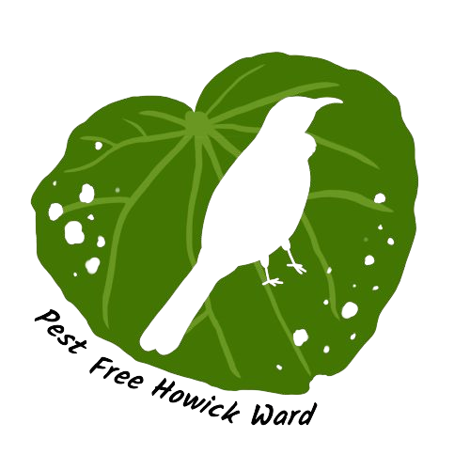

For more information, contact **mpc@pfhw.org.nz**