**How to control Moth plants and use herbicide gel**

# Manual removal

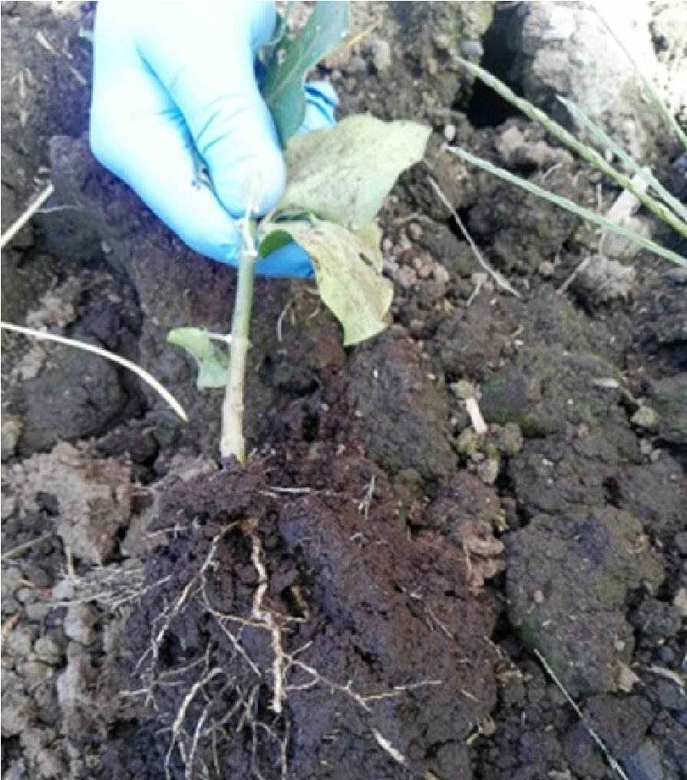For smaller infestations, dig and pull out seedlings and vines if practical. Ensuring most of the root system has been removed.

# Chemical application

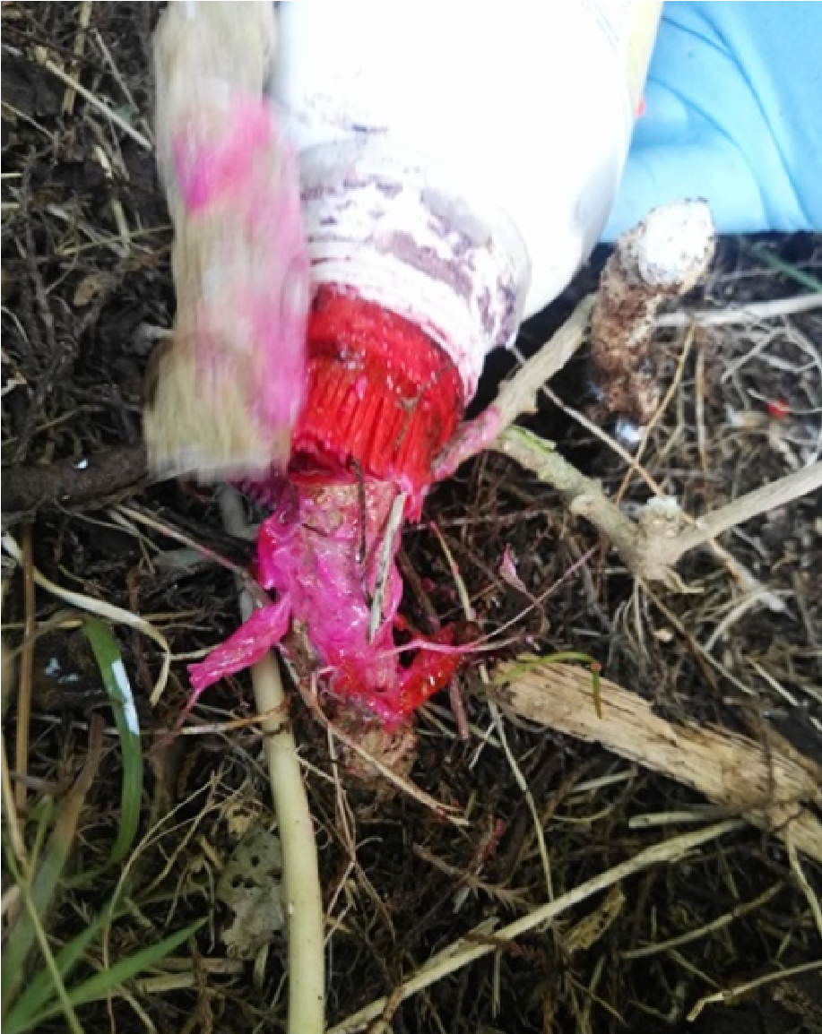If you cannot dig out the plant, cut vines near the ground leaving approximately 10cm showing. Ensure to paste the stem and sides with the Herbicide gel provided.

Herbicide gel should be applied immediately to the cut stem - certainly no longer than one minute after you’ve made the initial cut.

When using any herbicide **PLEASE READ THE LABEL THOROUGHLY** to ensure

that all instructions and safety requirements are followed.

**To find out more please contact:**

mpc@pfhw.org.nz

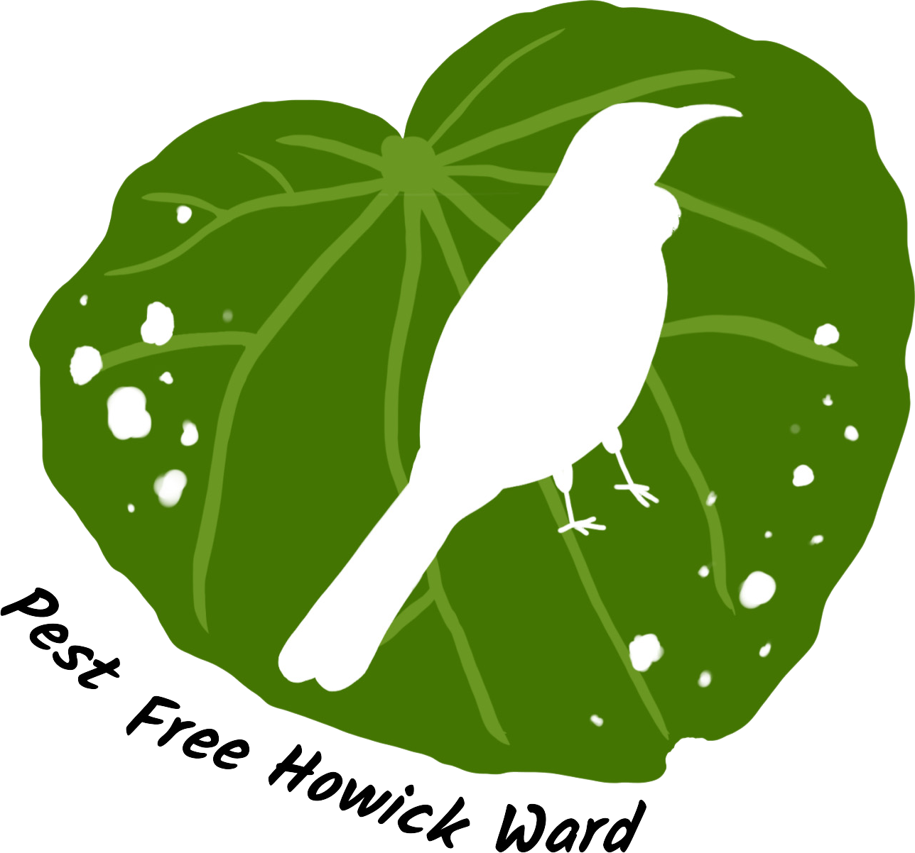

**How to control Moth plants and use herbicide gel**

**Do’s** and **Don’ts** when using herbicide gel

**Do’s**

* Store in a closed, original container in a dry, cool, well-ventilated area out of direct sunlight.
* Ensure all the gel is applied to the target and away from any non-target species.

Herbicide gel is highly residual and can remain in the soil for a long time.

* Wear safety glasses, gloves, long pants and long-sleeved clothing when using herbicide gel.

**Don’ts**

⨯ Do not use if rain is likely to fall within 12 hours of application.

⨯ Do not burn empty containers.

⨯ Do not compost treated plants.

# Collection and disposal

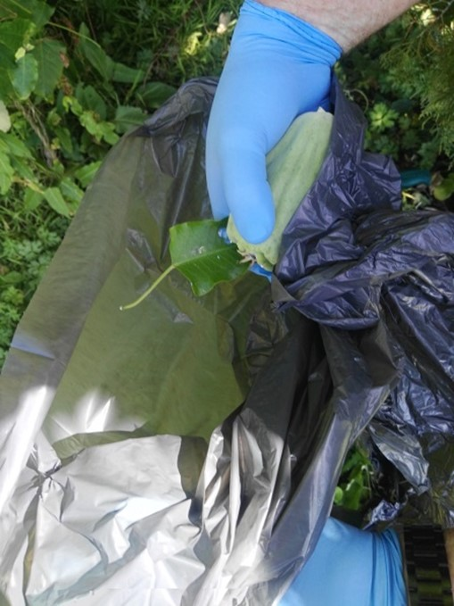We encourage you to drop moth plant pods and vines off at the **Pakuranga Plaza carpark from 9-11am on the following dates; 23 March, 13 April, or 27 April**, or at the Howick Local Board disposal bins in **Lloyd Elsmore Park from 10 May to 13 May.** This way the pods can be taken to a hot composting facility.

Cut vines can be left in trees to die.

It is recommended that you wear safety glasses, gloves and long pants when doing moth plant work, as the milky-white sap is a skin irritant.

Please return all unused herbicide gel, reusable gloves and protective eyewear to your teacher in charge, so we can use it again next year!

**To find out more please contact:**

mpc@pfhw.org.nz

